1st Annual
Copiague H.S.’s
STEEPLE CHALLENGE
Copiague High School---1100 Dixon Avenue---Copiague, NY

Friday April 4, 2014 4:00pm



- 3000 & 2000m Steeplechase
  - Separate Frosh & Soph 2000 races and separate Varsity 2000 & 3000 races
- Shot Put & Discus
  - Both Boys & Girls
- Long & Triple Jump
  - Boys Long Jump & Girls Triple Jump Only
- High Jump
  - Both Boys & Girls
- Pole Vault
  - Both Boys (opening height 10’) & Girls (opening height 7’)

Walter G. O’Connell-Copiague HS
1st Annual
Copiague H.S.’s
STEEPLE CHALLENGE

Friday April 4, 2014 4:00pm
Copiague High School---1100 Dixon Avenue---Copiague, NY

Clerking: Begins at 3:45pm
- This meet is open to all HS boys and girls.
- Athletes may compete in any three (3) events.

Awards:
- Medals will be given to the top three finishers in all events, with a distinctive 1st place

Spikes:
- ¼ in maximum length can be worn on all runways and the track.

Food:
- Hot BBQ & cold food and drinks will be on sale the day of the meet, as well as Invite T-shirts.
Please support the Copiague Booster Club.
Timing:
- F.A.T. from Tony Toro & http://www.just-in-time-racing.com/default.htm

Entry Fees:
- Section XI teams: $125.00 blanket fee, or $10.00 per individual
  - Boys & Girls combined team: $200.00
- Non-Section XI teams: $150.00 blanket fee, or $10.00 per individual
  - Boys & Girls combined: $250.00

WE’VE KEPT OUR ENTRY FEE LOW TO REFLECT FISCAL RESTRAINT.

- Blanket Fee: allows for unlimited individual entries.
- Meet will be limited to the first 25 teams with paid entry!

Walter G. O’Connell-Copiague HS
1st Annual

STEEPLE CHALLENGE

Friday April 4, 2014 4:00pm
Copiague High School---1100 Dixon Avenue---Copiague, NY

ORDER OF STEEPLECHASE
RUNNING EVENTS START AT 4:00 PM
- Girls Events Followed by Boys
- Verbal seeds for all running events
- ALL ATHLETES MUST USE THEIR “JUST-IN-TIME ISSUED COMPETITOR NUMBER!!!

- 2000m Steeple Freshman Girls
- 2000m Steeple Freshman Boys
- 2000m Steeple Sophomore Girls
- 2000m Steeple Sophomore Boys
- 2000m Steeple Varsity Girls
- 2000m Steeple Varsity Boys
- 3000m Steeple Varsity Girls
- 3000m Steeple Varsity Boys

FIELD EVENTS START AT 4:00PM
  - Seed cards will be used for all field events
  - There will be NO triple jump
- ALL ATHLETES MUST HAVE A COMPETITOR NUMBER!!!

Walter G. O’Connell-Copiague HS
1st Annual
STEEPLE CHALLENGE

Friday April 4, 2014 4:00pm
Copiague High School---1100 Dixon Avenue---Copiague, NY

Entries Due: March 28th, 2014
Entries received after may be denied entry.
Meet will be limited to the first 25 teams with paid entry!

School: ___________________________________ _ (circle one) BOYS GIRLS

Coach’s Name: _______ ___________________________________________

Coaches Email: _____________________________________________ ____

School Phone # (____) _________________ Coach’s Phone # (____) __________________

Entry Fees:
- Please circle one Section XI team OR Non-Section XI team
If using blanket fee: $100.00 $150.00

Combined Teams OR Combined Teams
B/G Section XI B/G Non-Section XI
$200.00 $250.00 OR

- # of individuals ___________ X $10.00 each = ____________

      - TOTAL AMOUNT DUE = ____________

This is an entry fee not a participation fee & the meet will be capped at 25 teams.

Make checks or PO’s payable to Copiague High School and send to:

COPIAGUE H.S.---c/o George Schroeder---1100 Dixon Avenue---Copiague, New York 11726
Questions---Comments---Concerns
Contact---George Schroeder email at gschroeder@copiague.net or call 516-672-4086 (cell)

Walter G. O’Connell-Copiague HS
1st Annual
STEEPLE CHALLENGE

COPIAGUE HS TRACK & FIELD RECORDS

Boys Girls

10:16.7--- Wes Merriwether- Copiague “12 3000/2000 Steeple 7:04.17---Victoria Ingram---Smithtown W “13

54-02 ---Ben Bonhurst--- Smithtown W “13 SHOT 37-00.75 ---Tiara Davis---HHHW “13

164-02 ---Ben Bonhurst--- Smithtown W “13 DISC 103-01 ---Tiara Davis---HHHW “13

21’08.5---Alex Williams---Wyandanch- “12 LONG JUMP 18-05.25---Janel Francis---Copiague “12

44-03----Justin Brown---Copiague “12 TRIPLE JUMP 40’02.75”---Meloney Riley---Riv. “12

6-04 ---Maurice Epps---Copiague “13 HIGH JUMP 5-02 ---Carly Swinford---Sachem N “13
---Wade Richardson---Copiague “11

14-00 --- Jonah Spaeth--- Riverhead “13 Pole Vault not contested
--- Dan Normoyle---Riverhead “13

“Most people run a race to see who is fastest. I run a race to see who has the most guts.”
---Steve Prefontaine

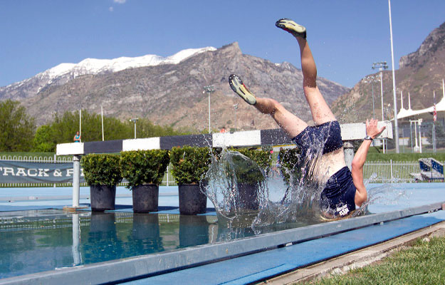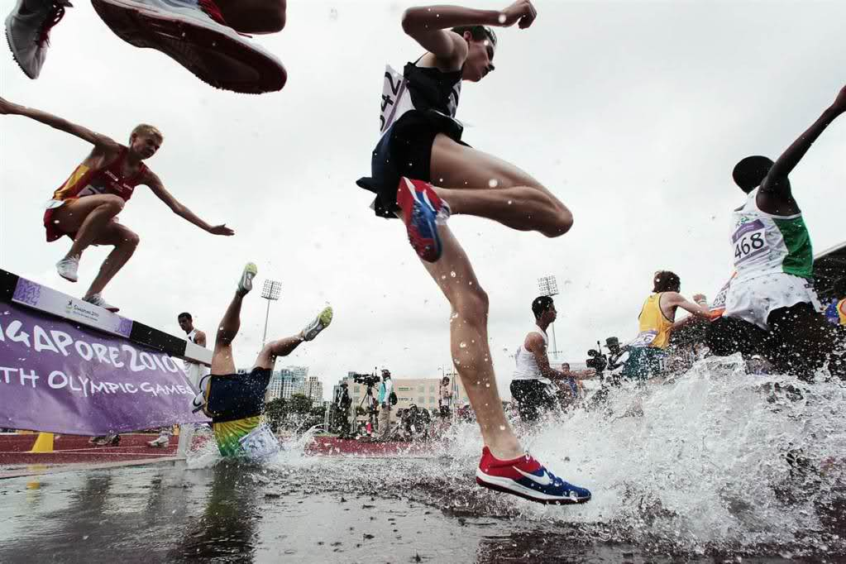

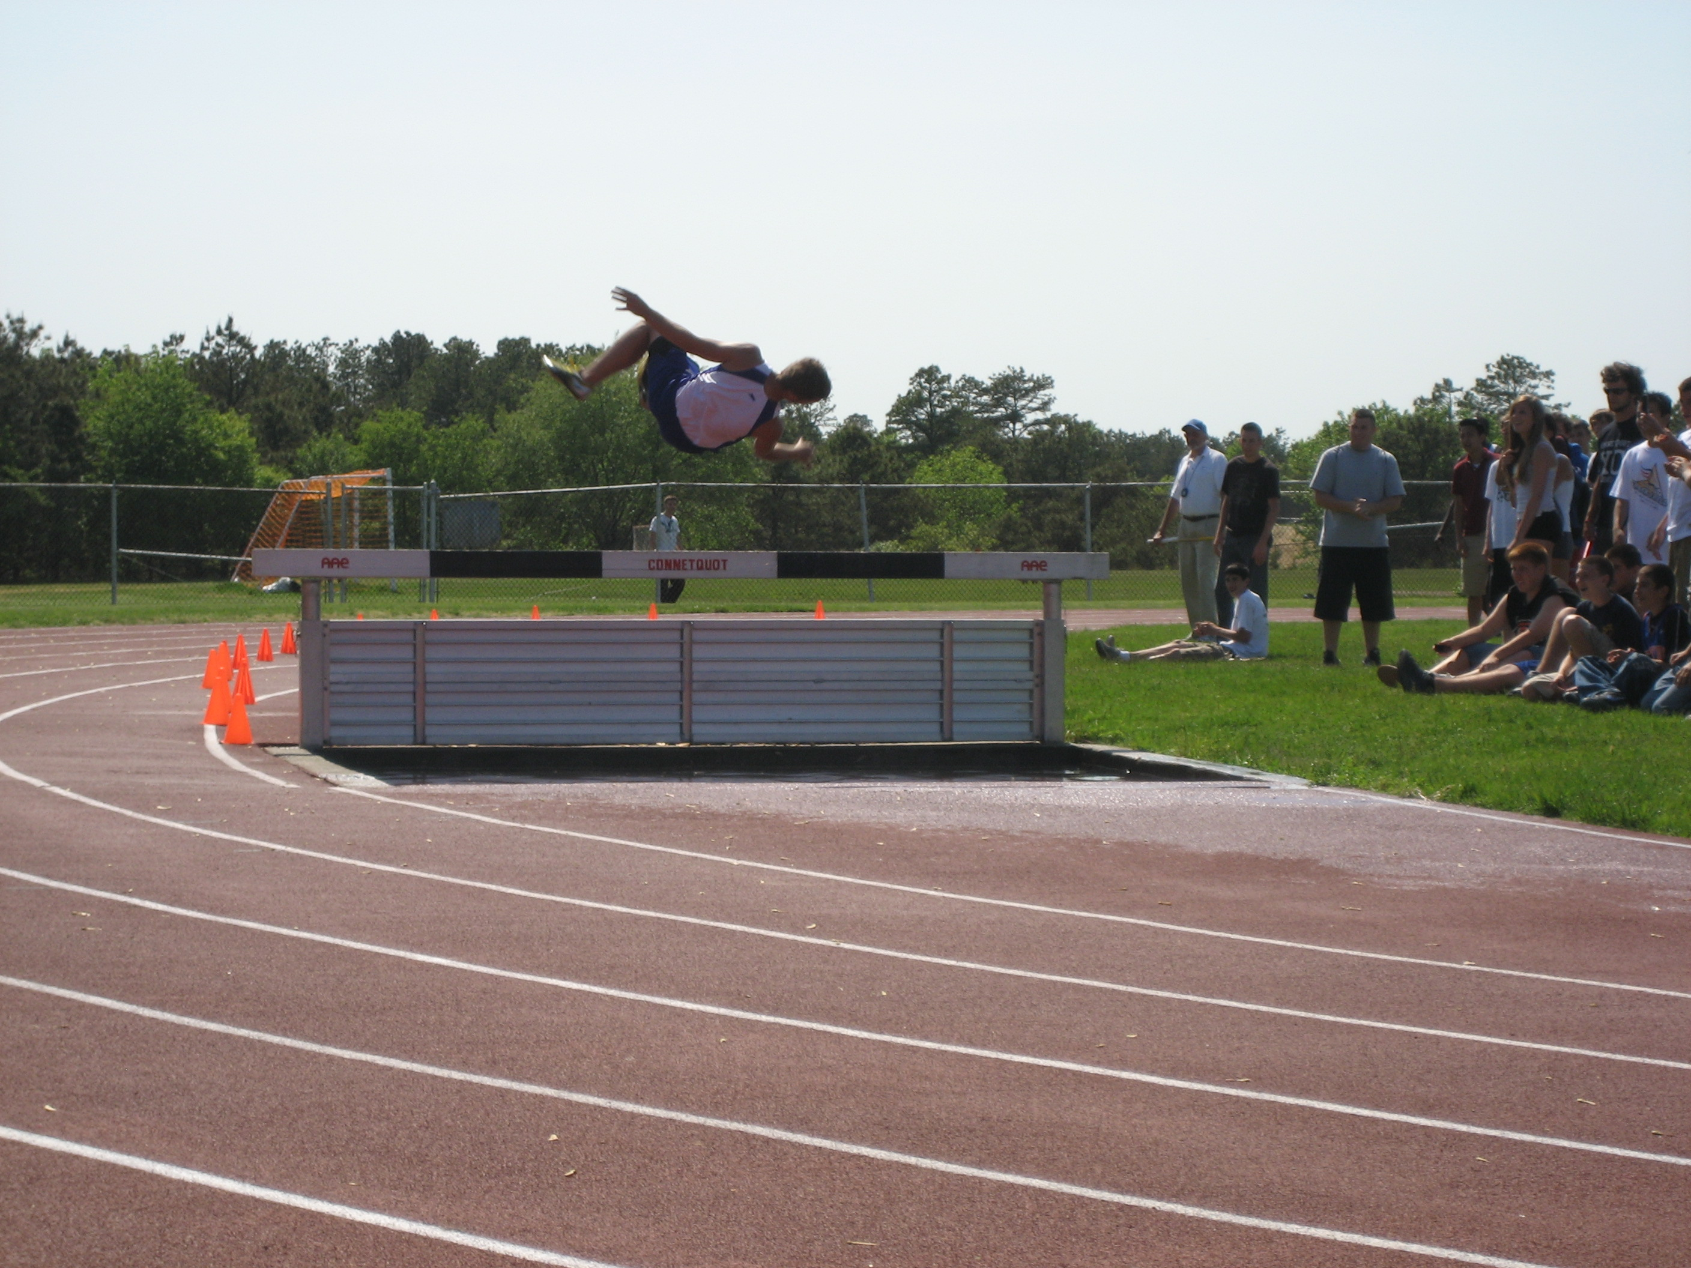

- The steeplechase is a difficult event, and it can be dangerous.

- If you commit an act of un-sportsmanship (see the photo to the right), you & your entire team may be disqualified from the event AND the meet.


